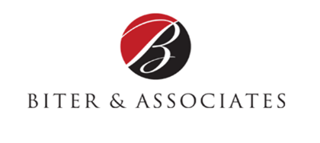

Constant Contact Article | Open Enrollment | Article #3
Goal Setting for Your Team & How to Avoid Information Overload
By Cindy Biter, Managing Partner, Biter & Associates, LLC
In my last article, I talked about taking the information received in the employee survey you conducted to determine what’s most important for this years’ Open Enrollment. Now that you’ve determined the key factors that you’d like to accomplish, it’s time to set some goals for you and your team.
What are common goals for a successful Open Enrollment? What exactly do you want employees to do? While every organization has different priorities, many have goals targeting enrollment, engagement, and HR budgets and productivity. A few examples are:
• Increase enrollment in company’s health plan by X%
• Get X% of employees saving for retirement
• Engage X% of employees in wellness programs
Focus on only the most important or relevant goals in order to save time, energy and man-power. Another good way to measure the goals you’ve accomplished is by using tools and solutions offered by third-party vendors. Digital communication enables you to easily track user activity and measure your efforts.
Avoid Information Overload
Don't overwhelm employees with all the information at once. Communicate new information first and concentrate on one benefit at a time. Normally your health insurance plan will be the benefit that has the most changes in it. Concentrate only on health insurance in your initial communication, then move on from there, carefully considering what major benefit changes will take place and how they’ll affect your employees.
If you’re using an online service for benefit changes, make sure all employees know how to log in and make changes themselves. Hold some classes on "How Do I Use the Open Enrollment Online System." If your employees are pressed for time, spend a day making a short instructional video on the use of the system. Many companies have video capabilities, YouTube channels and other tools to make this process simple. Videos allow the employee to take time while reviewing benefit plan choices.

