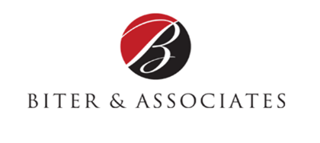

Constant Contact Article | Open Enrollment | Article #2
KISS
By Cindy Biter, Managing Partner, Biter & Associates, LLC

Keep it simple, sweetie!
In my last article, I suggested sending a short online survey to your employees asking them several pointed questions about last years’ Open Enrollment process. After you’ve received the majority of responses, review the replies and pinpoint your primary and secondary goals for this years’ event. Whatever your objectives are, make sure to name them and set a goal and a stretch-goal for both.
Clients have shared with me that many times, that employees wait till the last minute, or worse yet, they don’t do anything because they are overwhelmed with all the information, or worse yet, they don’t understand it.
Take some time to review the information you provided in last years’ Open Enrollment guide. Ask yourself some basic questions, looking at the information and the process from the employees’ point of view: How did we present the information? What would have made this information easier to understand? Remember, you understand the process, but most of your employees don’t.
There’s an old adage that goes something like this:
“When you don’t know where you’re going, any road will get you there.”
That’s NOT the road you want to be on for Open Enrollment. Take the information you received from your employee survey, as well as the information you acquired from last years’ Open Enrollment and determine your goals and what success will look like. These goals will become your anchor-points and benchmarks for all of your team meetings, keep them in mind to enable your team to focus on what’s the most important and what a successful Open Enrollment will look like, not only from your point of view, but from the employees’ point of view.
The bottom line is, the goals you choose to focus on will drive everything in your Open Enrollment campaign. You may be tempted to have a lot of goals. Don’t give in to this temptation. Focus on a few areas that REALLY matter, specifically those that align with your business goals and the satisfaction of your employees.
In my next article, I’ll focus on goal-setting for your team for Open Enrollment and ways to avoid Information Overload.

